#### **Data Encapsulation**

* Data Encapsulation is the process in which some extra information is added to the data item to add some features to it.
* We use either the OSI or the TCP/IP model in our network, and the data transmission takes place through various layers in these models. Data encapsulation adds the protocol information to the data so that data transmission can take place in a proper way. This information can either be added in the header or the footer of the data.
* The data is encapsulated on the sender’s side, starting from the application layer to the physical layer. Each layer takes the encapsulated data from the previous layer and adds some more information to encapsulate it and some more functionalities with the data. These functionalities may include proper data sequencing, error detection and control, flow control, congestion control, routing information, etc.

#### **Data De-encapsulation**

* Data De-encapsulation is the reverse process of data encapsulation. The encapsulated information is removed from the received data to obtain the original data.
* The process takes place at the receiver’s end. The data is de-encapsulated at the same layer at the receiver’s end to the encapsulated layer at the sender’s end. The added header and trailer information are removed from the data in this process.
* The below diagram shows how header and footer are added and removed from the data in the process of encapsulation and de-encapsulation respectively.

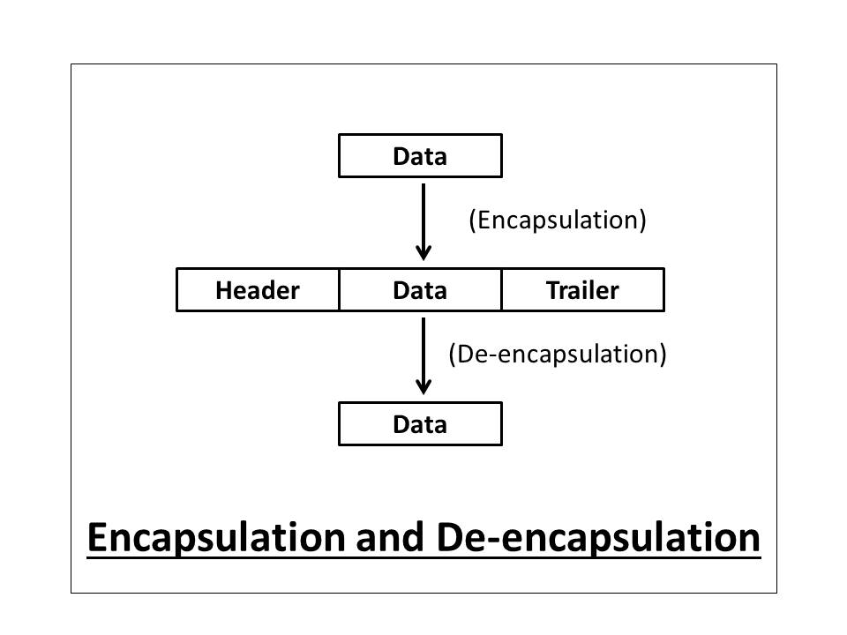

The data is encapsulated in every layer at the sender’s side and also de-encapsulated in the same layer at the receiver’s end of the [OSI or TCP/IP model](https://afteracademy.com/blog/which-model-is-better-osi-or-tcpip). Actually, we use different terms for the encapsulated form of the data that is described in the below-mentioned diagram.

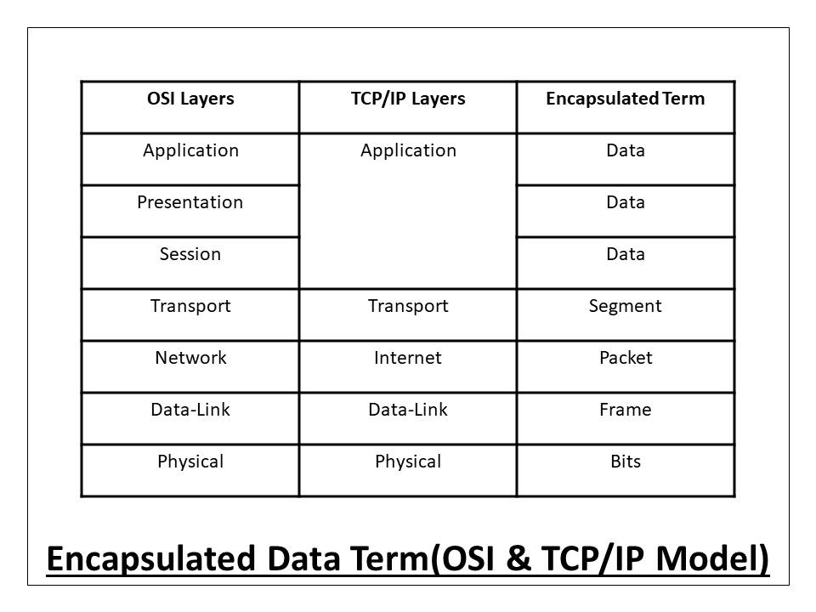

Now, we will learn the whole process of encapsulation and de-encapsulation in the [OSI and TCP/IP model](https://afteracademy.com/blog/which-model-is-better-osi-or-tcpip) step-by-step as mentioned in the below picture.

